**India’s Agricultural Crop Production Analysis**

**1. Introduction**

**1.1. Overview:**

Tableau is a powerful and fastest growing data visualization tool used in the Business Intelligence Industry. It helps in simplifying raw data in a very easily understandable format. Tableau helps create the data that can be understood by professionals at any level in an organization. It also allows non-technical users to create customized dashboards. Data analysis is very fast with Tableau tool and the visualizations created are in the form of dashboards and worksheets.

The best features of Tableau software are

* Data Blending
* Real time analysis
* Collaboration of data

The great thing about Tableau software is that it doesn’t require any technical or any kind of programming skills to operate. The tool has garnered interest among the people from all sectors such as business, researchers, different industries, etc. Indian Agricultural productivity depends on several factors.  These include the availability and quality of agricultural inputs such as land, water, seeds and fertilizers, access to agricultural credit and crop insurance, assurance of remunerative prices for agricultural produce, and storage and marketing infrastructure, among others.  This report provides an overview of the state of agriculture in India.  It discusses factors related to the production in agriculture.

* 1. **Purpose**
* The main purpose of the project is to create different visualization of any two of fields from Indian agriculture production dataset such as area VS production, Season base cultivation, Yield by season , Crop plantation by area, major crops growth yield of year, Crop plantation by count etc., and create dashboard and story. From the dashboard and story identify the problem and give solution.

**2. Problem Definition & Design Thinking**

2.1 Empathy Map

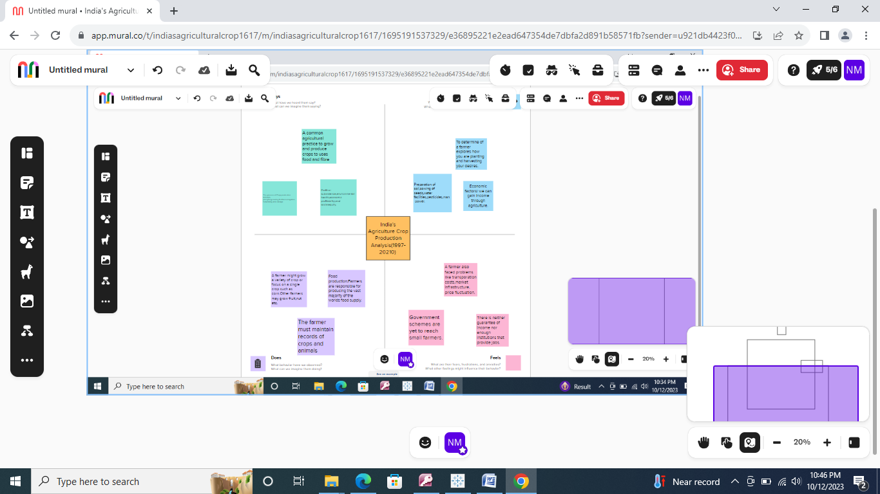

2.2 Ideation & Brainstorming Map

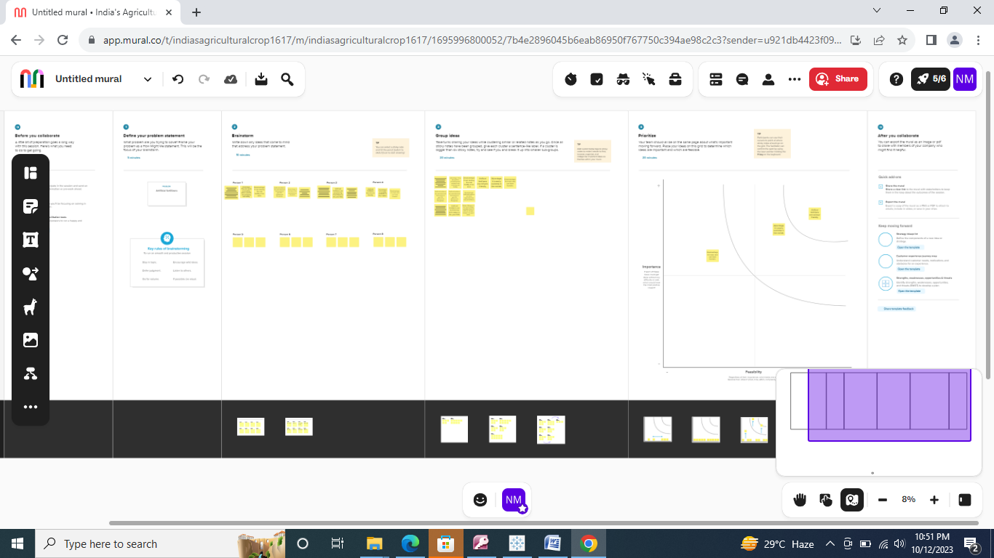

**3. RESULT**

**3.1. Area Vs Production**

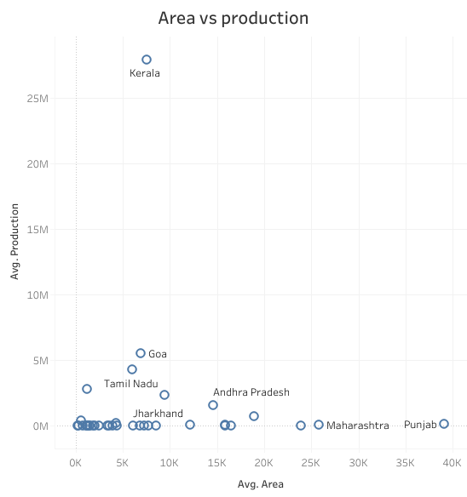

This scattered chart shows the area vs production visualization. From this chart we have observed huge amount of production obtain in small area. However low amount of production rate obtains in huge area. This results clearly indicates production independent of area.

**3.2 Season Based Cultivation**

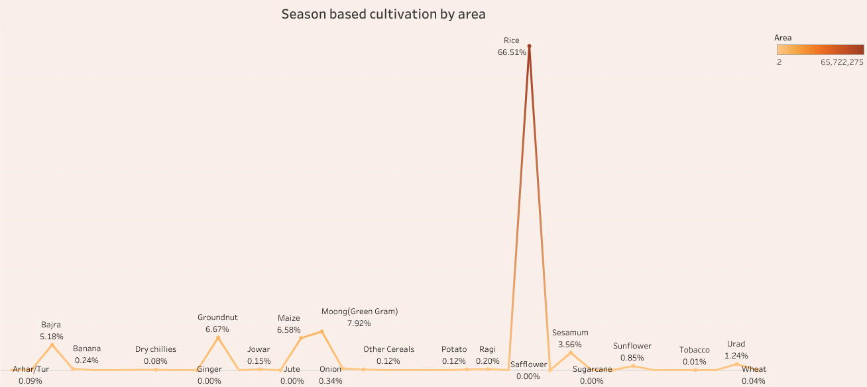

This line chart shows the season-based cultivation by area. The maximum percentage of area cultivated rice crops (66.51%.) and minimum percentage of area cultivated sunflower crop (0.85%.) was observed. Therefore, rice crop cultivation cover the majority area.

**3.3. Yield by season**

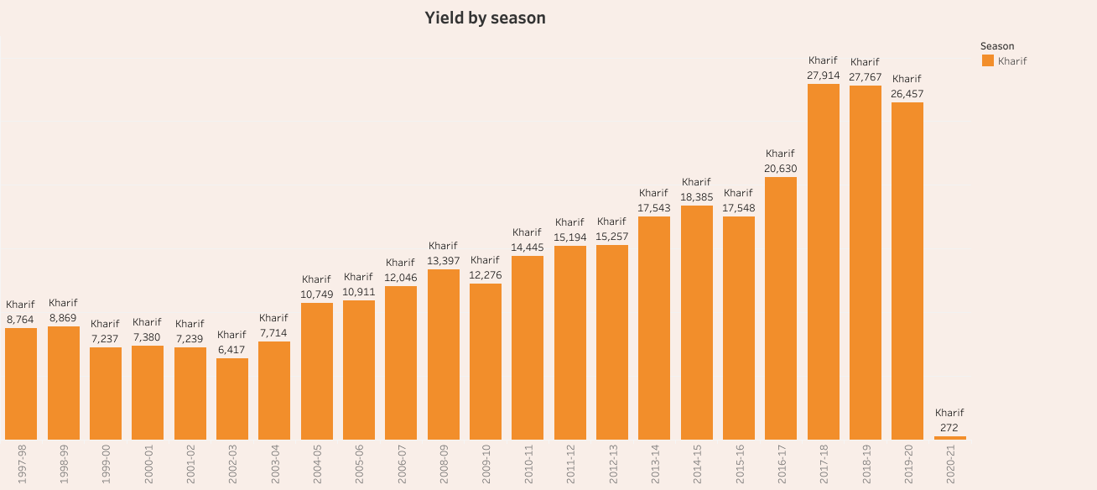

This bar chart shows the yield by kharif season. In kharif season maximum percentage of yield observed in 2017-18 year and minimum percentage of yield observed in the year of 2020-21

3.4.Crop Planation by area

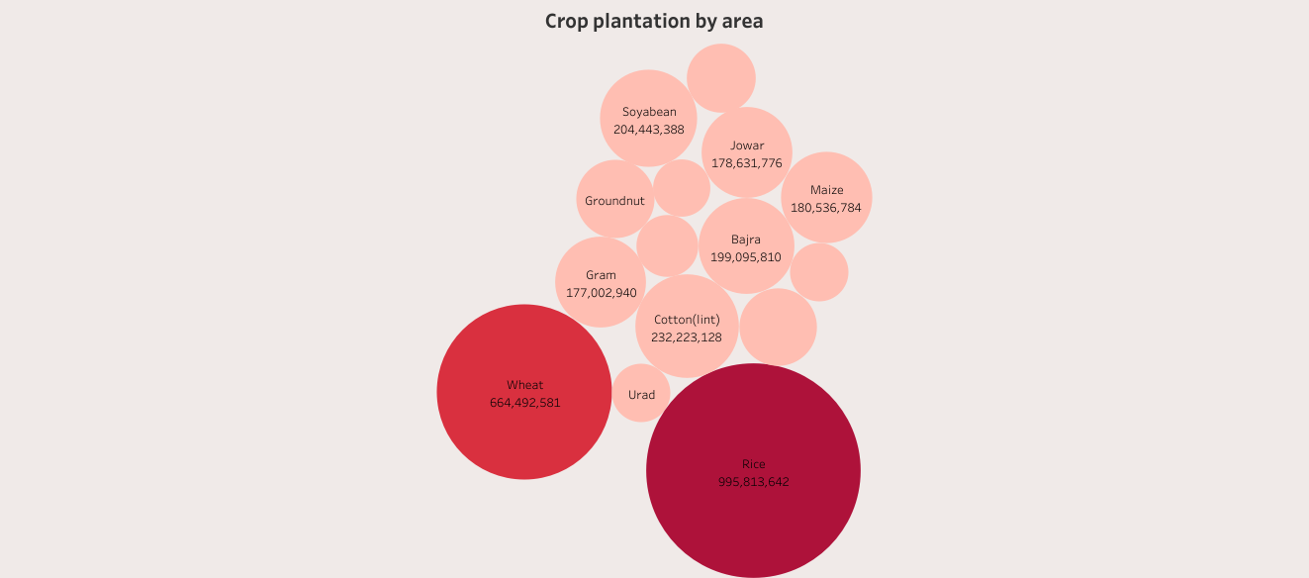

The bobbles chart shows the crop planation by area. This visualization clearly shows rice crop is the major planation area. Moreover, urad and groundnut plantation cover in very few areas.

**3.5. Major crops growth yield of year**

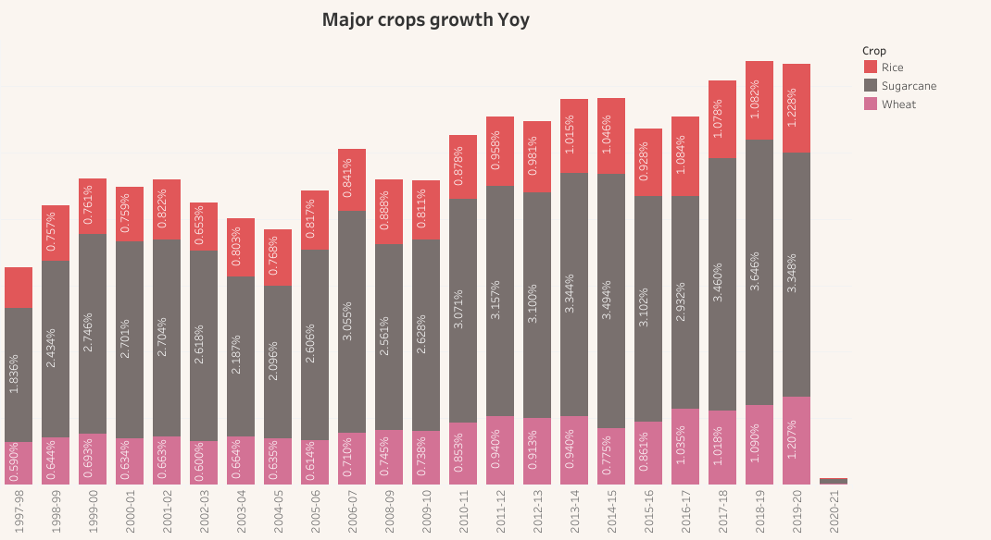

This bar charts shows major growth yield of year. This visualization shows the major crop growth are observed in year of 2018-19. Moreover, in year of 2018-19 sugarcane, rice and wheat is the major grown crops.

3.6.Crops plantation by count

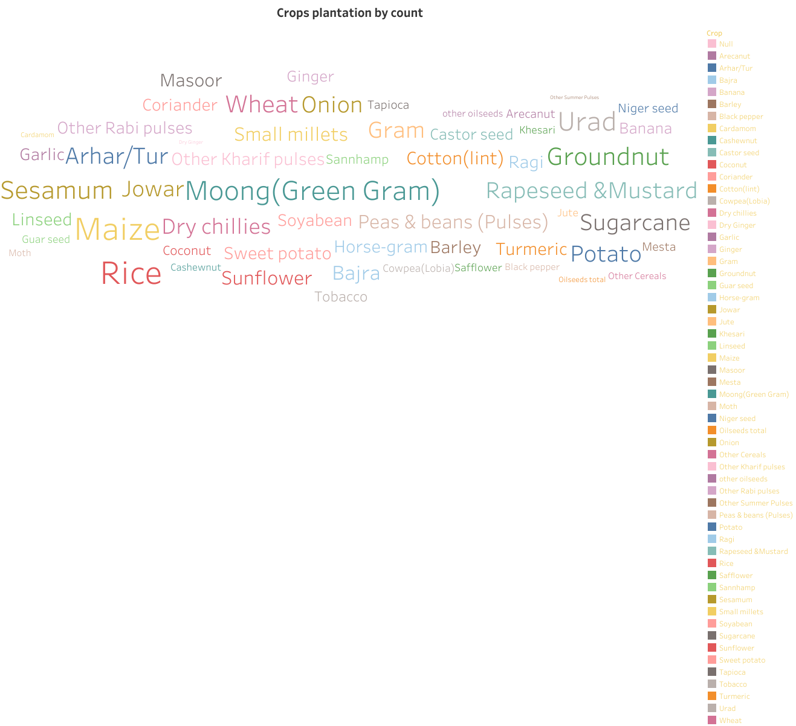

The text chart shows the crops plantation by count. The text charts clearly show rice crop plantation have higher count. Remaining crops such as wheat, maize and green gram are shows the next level plantation count rate.

4..**Advantages & Disadvantages**

It provide farmer granular data on rainfall pattern, water cycle fertilizer requirement, choice of crop in particular land and more. This enables them to make smart decision. The right decision ultimately improves farm yields. However, take more time, high cost, need skilled persons are some of disadvantages .

**5. APPLICATION**

Data analytics provide a farmer with useful information to support their decision-making process, such as soil data inform decision on type and amount of fertilizer to be used. while sensor data allow monitoring plants and livestock’s growth and health.

**6.Conclusion**

In this project we analyze the production of Indian agriculture. From the analyses we have observed following results. Crop production are independent of area. The rice crop (66.51%.) cultivated the maximum percentage of area and sunflower crop (0.85%.) cultivated minimum percentage of area. In kharif season maximum percentage of yield observed in 2017-18 year and minimum percentage of yield observed in the year of 2020-21 The bobbles visualization clearly shows rice crop is the major planation area. Moreover, urad and groundnut plantation cover in very few areas. The major crop growth is observed in year of 2018-19. Moreover, in this year sugarcane, rice and wheat is the major grown crops. The text charts clearly show rice crop plantation have higher count. Remaining crops such as wheat, maize and green gram are showing the next level plantation count rate. From the result we have conclude that rice crop plays major role in India agriculture production.

**FUTURE SCOPE**

* To create visualization fertilizer vs land
* To create visualization cultivation expense Vs crop etc.,